Al-salam Elementary School

A worksheet for the 4th graders

**Colors**

**Name:________ date:15.10.2020**

1. **Read the following words اقرأ الكلمات التاليه**

red احمر

blue ازرق

green اخضر

yellow اصفر

purple بنفسجي

brown بني

black اسود

grey رمادي

white ابيض

pink زهري

1. Write in Capital letters اكتب بحروف كبيره

مثال red: RED

1. green:________
2. black:______
3. pink:______
4. blue:_______
5. white:________
6. circle احط بدائره حول الجمله املائمه للصوره
7. A blue pen

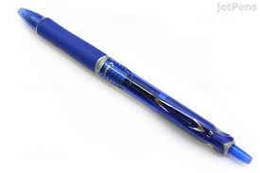 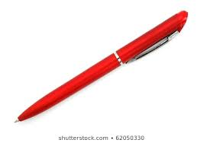

1. A red pencil

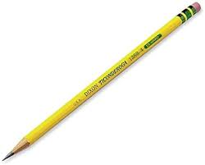 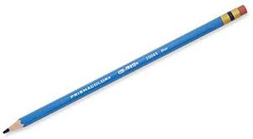

1. A green book

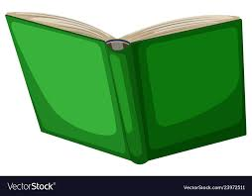 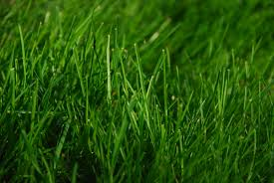

1. A black cat

 

1. A pink bag

